Monday, 4 November 2024

**Question 1**:

Question 2: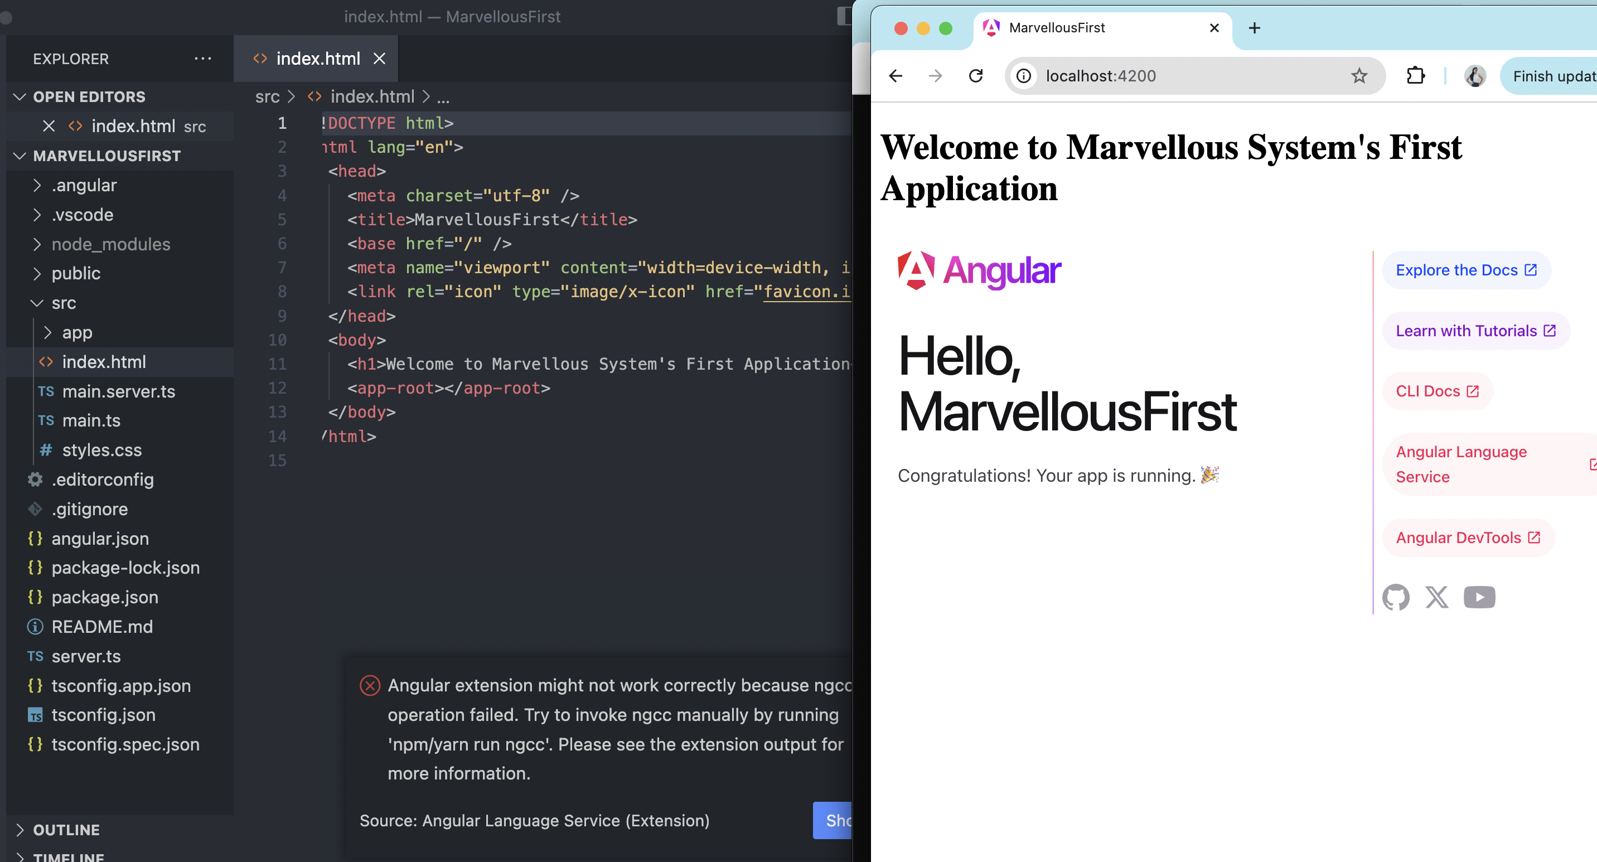

Question3

Not succeeded in this question resolution. Missing something and getting this error.

Unable to recall component part . I am sorry. 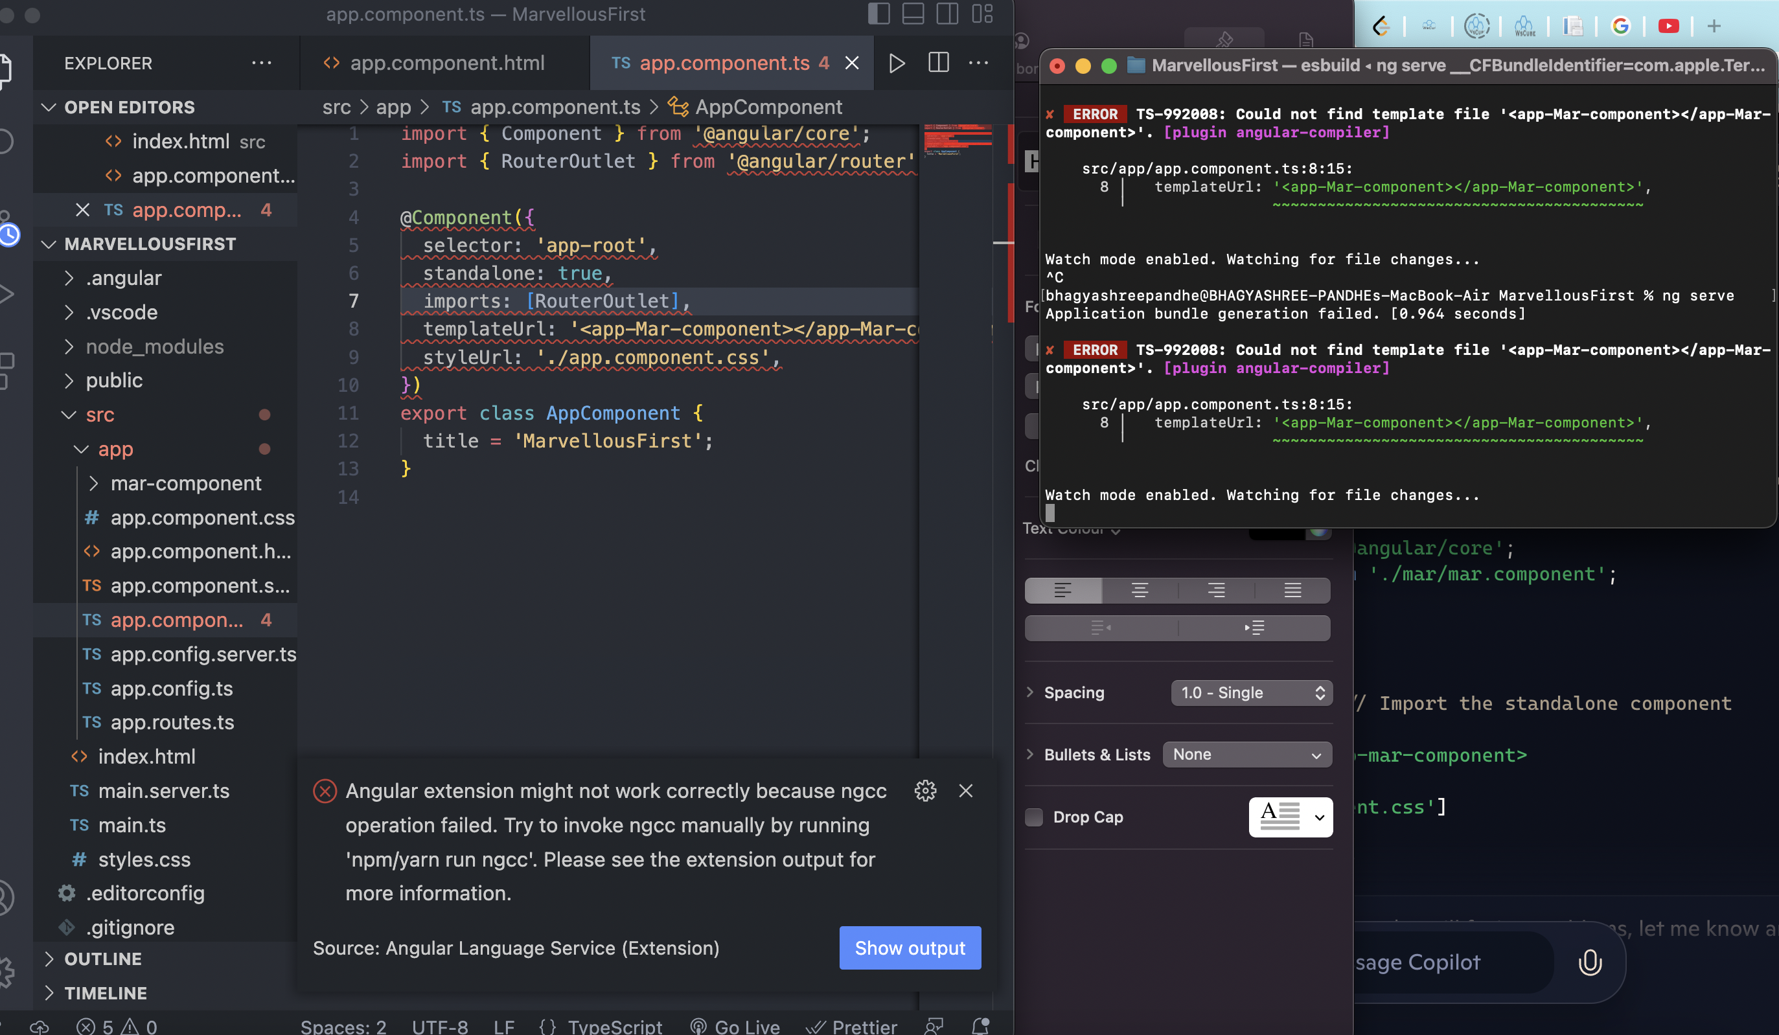

Question 4:Unable to fix this error, came after adding the component name . 